CO4 AT-1
CSA0911
INDUSTRIAL PROBLEM SOLVING
1.
import javax.swing.*;
import javax.swing.table.DefaultTableModel;
import java.awt.*;
public class InventoryManagementDashboard extends JFrame {
JTextField idField, nameField, qtyField, priceField, searchField;
JTable table;
DefaultTableModel model;
public InventoryManagementDashboard() {
setTitle("Inventory Management Dashboard");
setSize(900, 600);
setDefaultCloseOperation(JFrame.EXIT_ON_CLOSE);
setLocationRelativeTo(null);
JLabel title = new JLabel("Inventory Management Dashboard",
SwingConstants.CENTER);
title.setFont(new Font("Arial", Font.BOLD, 24));
JPanel formPanel = new JPanel(new GridLayout(2, 5, 10, 10));
idField = new JTextField();
nameField = new JTextField();
qtyField = new JTextField();
priceField = new JTextField();
formPanel.add(new JLabel("Product ID"));
formPanel.add(new JLabel("Product Name"));
formPanel.add(new JLabel("Quantity"));
formPanel.add(new JLabel("Price"));
formPanel.add(new JLabel(""));
formPanel.add(idField);
formPanel.add(nameField);
formPanel.add(qtyField);
formPanel.add(priceField);
JButton addButton = new JButton("Add");
formPanel.add(addButton);
JButton updateButton = new JButton("Update");
JButton deleteButton = new JButton("Delete");
JButton clearButton = new JButton("Clear");
JPanel buttonPanel = new JPanel();
buttonPanel.add(updateButton);
buttonPanel.add(deleteButton);
buttonPanel.add(clearButton);
searchField = new JTextField(20);
JButton searchButton = new JButton("Search");
JPanel searchPanel = new JPanel();
searchPanel.add(new JLabel("Search:"));
searchPanel.add(searchField);
searchPanel.add(searchButton);
String[] columns = {"Product ID", "Product Name", "Quantity", "Price"};
model = new DefaultTableModel(columns, 0);
table = new JTable(model);
JScrollPane scrollPane = new JScrollPane(table);
addButton.addActionListener(e -> {
if (idField.getText().isEmpty() ||
nameField.getText().isEmpty() ||
qtyField.getText().isEmpty() ||
priceField.getText().isEmpty()) {
JOptionPane.showMessageDialog(this,
"Please enter all product details.");
return;
}
model.addRow(new Object[]{
idField.getText(),
nameField.getText(),
qtyField.getText(),
priceField.getText()
});
clearFields();
});
updateButton.addActionListener(e -> {
int row = table.getSelectedRow();
if (row == -1) {
JOptionPane.showMessageDialog(this,
"Select a product to update.");
return;
}
model.setValueAt(idField.getText(), row, 0);
model.setValueAt(nameField.getText(), row, 1);
model.setValueAt(qtyField.getText(), row, 2);
model.setValueAt(priceField.getText(), row, 3);
clearFields();
});
deleteButton.addActionListener(e -> {
int row = table.getSelectedRow();
if (row == -1) {
JOptionPane.showMessageDialog(this,
"Select a product to delete.");
return;
}
model.removeRow(row);
clearFields();
});
clearButton.addActionListener(e -> clearFields());
table.getSelectionModel().addListSelectionListener(e -> {
int row = table.getSelectedRow();
if (row != -1) {
idField.setText(model.getValueAt(row, 0).toString());
nameField.setText(model.getValueAt(row, 1).toString());
qtyField.setText(model.getValueAt(row, 2).toString());
priceField.setText(model.getValueAt(row, 3).toString());
}
});
searchButton.addActionListener(e -> {
String search = searchField.getText().toLowerCase();
for (int i = 0; i < model.getRowCount(); i++) {
String name = model.getValueAt(i, 1)
.toString().toLowerCase();
if (name.contains(search)) {
table.setRowSelectionInterval(i, i);
return;
}
}
JOptionPane.showMessageDialog(this,
"Product not found.");
});
setLayout(new BorderLayout(10, 10));
add(title, BorderLayout.NORTH);
JPanel topPanel = new JPanel(new BorderLayout());
topPanel.add(formPanel, BorderLayout.CENTER);
topPanel.add(buttonPanel, BorderLayout.SOUTH);
add(topPanel, BorderLayout.CENTER);
add(scrollPane, BorderLayout.SOUTH);
add(searchPanel, BorderLayout.PAGE_END);
setVisible(true);
}
void clearFields() {
idField.setText("");
nameField.setText("");
qtyField.setText("");
priceField.setText("");
}
public static void main(String[] args) {
SwingUtilities.invokeLater(() ->
new InventoryManagementDashboard());
}
}

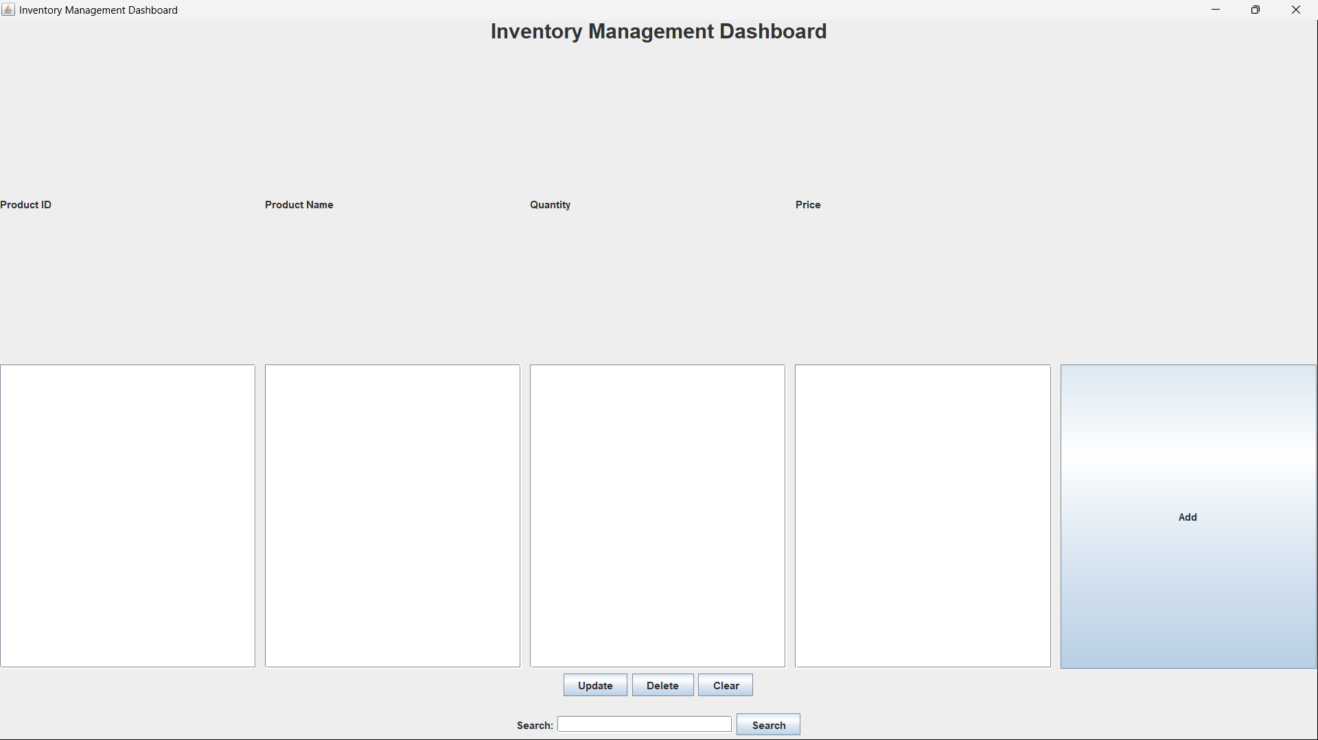
OUTPUT

